SHOPIFY SALES ANALYTICS
An Interactive Power BI Dashboard for Sales, Customer & Product Analysis
PROJECT REPORT
Project Domain
Business Intelligence & Data Analytics
Project Title
Shopify Sales Analytics Dashboard
Developed Using- Microsoft Power BI
Prepared By- YashVardhan Yadav
Academic Year- 2026

PROJECT OVERVIEW
The Shopify Sales Analytics project is an interactive Business Intelligence dashboard developed using Microsoft Power BI to analyse Shopify sales performance, customer behaviour, product performance, customer value, retention and transaction-level data.
The dashboard combines Key Performance Indicators (KPIs), interactive filters, visual analytics, dynamic business insights and recommendations to provide a consolidated view of business performance and support data-driven decision-making.
1. INTRODUCTION
1.1 Project Background
In the modern e-commerce environment, businesses generate large volumes of sales and customer transaction data. Analysing this data effectively is essential for understanding sales performance, customer behaviour, product demand and business growth.
Raw transaction data, however, can be difficult to interpret and does not provide decision-makers with an immediate overview of business performance.
The Shopify Sales Analytics project addresses this challenge by transforming Shopify transaction data into an interactive Business Intelligence dashboard using Microsoft Power BI. The dashboard presents important business metrics through KPIs, charts, filters and detailed analytical views.
1.2 Project Purpose
The primary purpose of this project is to provide an interactive platform for analysing Shopify business performance from multiple perspectives.
The dashboard enables users to:
- Monitor Total Orders, Total Revenue, Unique Customers and Average Order Value.
- Analyse new and returning customer behaviour.
- Evaluate product and product-type performance.
- Analyse revenue, quantity sold and order performance.
- Measure customer retention and repeat purchasing behaviour.
- Evaluate customer value using metrics such as Customer Lifetime Value.
- Analyse customer distribution across cities.
- Compare payment gateway performance.
- Investigate detailed transaction-level information.
- Generate business insights and recommendations for decision-making.
1.3 Project Scope
The project covers the following major analytical areas:
- Executive Sales Analysis – Provides an overview of revenue, orders, customers, Average Order Value, payment gateways and sales trends.
- Customer Analytics – Analyses customer types, customer distribution, geographical concentration, revenue contribution and top customers.
- Product Performance Analysis – Evaluates products and product types using revenue, quantity sold, orders and Average Order Value.
- Customer Value & Retention Analysis – Measures repeat purchase rate, purchase frequency, purchase gap, revenue per customer and estimated Customer Lifetime Value.
- Executive Business Summary – Presents key business insights and recommendations derived from the dashboard analysis.
- Transaction-Level Analysis – Provides detailed information about customers, orders, products, quantities, payment gateways and revenue for deeper investigation.
1.4 Importance of the Project
The project provides a centralized analytical environment for understanding Shopify business performance without manually analysing individual transaction records.
Interactive Power BI visuals and filters allow users to explore the data across different business dimensions and identify important sales, customer and product patterns.
A key advantage of the dashboard is its ability to connect high-level KPIs with detailed transaction information, allowing users to move from summarized business performance to underlying records when deeper investigation is required.
The dashboard therefore supports both management-level performance monitoring and detailed business analysis.
1.5 Technology Used
Microsoft Power BI
Microsoft Power BI is the primary technology used to develop the dashboard. It is used for:
- Data modelling
- KPI and measure creation
- Interactive visualizations
- Filters and slicers
- Dashboard navigation
- Dynamic business insights
- Business reporting
The final solution is presented as an interactive Power BI dashboard containing multiple analytical pages and transaction-level views.
2. BUSINESS OBJECTIVES
The main objective of the Shopify Sales Analytics project is to develop an interactive Power BI dashboard that transforms Shopify sales data into meaningful business information and supports data-driven decision-making.
The key business objectives are as follows:
2.1 Analyse Overall Sales Performance
To monitor overall business performance using key sales indicators such as:
- Total Orders
- Total Revenue
- Unique Customers
- Average Order Value (AOV)
These KPIs provide a high-level view of the business's sales performance.
2.2 Analyse Customer Behaviour and Retention
To understand customer purchasing behaviour by analysing:
- New and Returning Customers
- Orders per Customer
- Revenue by Customer Type
- Repeat Purchase Rate
- Purchase Frequency
- Customer Lifetime Value
This helps evaluate customer contribution, repeat purchasing behaviour and long-term customer value.
2.3 Evaluate Product Performance
To identify high-performing products and product types by analysing:
- Product Revenue
- Quantity Sold
- Orders
- Average Order Value by Product Type
This enables the business to compare product categories and identify areas of strong and weak performance.
2.4 Analyse Geographical and Payment Performance
To understand customer concentration across cities and compare revenue contribution across different payment gateways.
This analysis helps identify important customer locations and understand the performance of different payment channels.
2.5 Enable Interactive Business Analysis
To provide a dynamic analytical experience through Power BI filters, slicers and visual interactions.
Users can analyse the dashboard based on dimensions such as:
- Gateway
- Product Type
- City
- Customer Type
This allows multiple business questions to be analysed through a single interactive dashboard.
2.6 Generate Business Insights and Support Decision-Making
To convert dashboard analysis into meaningful business insights and actionable recommendations.
The project aims to help decision-makers:
- Identify important sales and customer trends.
- Recognize high-performing products and customer segments.
- Evaluate customer retention opportunities.
- Investigate detailed transaction-level information.
- Take informed business decisions based on data.
Overall, these objectives ensure that the Shopify Sales Analytics dashboard functions not only as a reporting tool but also as a Business Intelligence solution for performance analysis and decision-making.
3. BUSINESS PROBLEM
3.1 Problem Statement
Shopify generates a large volume of sales and customer transaction data. However, raw transaction data does not provide a consolidated view of business performance.
It can be difficult to quickly analyse revenue, orders, customer contribution, product performance, retention, payment gateways and customer locations from individual transaction records.
Therefore, an interactive Business Intelligence dashboard is required to convert raw data into meaningful KPIs, visual analysis and actionable business insights.
3.2 Key Business Problems
3.2.1 Lack of Centralized Sales Analysis
The business needs a single view of important KPIs such as Total Orders, Total Revenue, Unique Customers and Average Order Value instead of analysing individual records separately.
3.2.2 Difficulty in Understanding Customers
It is important to understand the difference between new and returning customers, their revenue contribution and purchasing behaviour. Customer retention and long-term value also need to be evaluated.
3.2.3 Difficulty in Evaluating Products
With multiple products and product types, the business needs to identify high-performing categories based on revenue, quantity sold, orders and Average Order Value.
3.2.4 Limited Business Comparison
The business needs to compare performance across different cities, customer types, product types and payment gateways to identify important trends and opportunities.
3.2.5 Difficulty in Converting Data into Decisions
Raw numbers and charts alone may not provide clear managerial direction. Business users need meaningful insights, recommendations and the ability to investigate detailed transactions when required.
3.3 Proposed Solution
To address these problems, an interactive Power BI dashboard was developed.
The solution combines:
- KPI cards
- Interactive charts
- Filters and slicers
- Customer and product analysis
- Retention metrics
- Dynamic business insights
- Business recommendations
- Transaction-level details
This allows users to move from overall business performance to detailed analysis within a single reporting environment.
3.4 Expected Business Benefits
The dashboard helps users to:
- Monitor overall sales performance.
- Understand customer behaviour and retention.
- Identify high-performing products.
- Compare cities and payment gateways.
- Analyse business trends interactively.
- Investigate transaction-level details.
- Support data-driven business decisions.
Overall, the solution converts raw Shopify transaction data into a centralized, interactive and decision-oriented Business Intelligence dashboard.
4. DATA & DASHBOARD METHODOLOGY
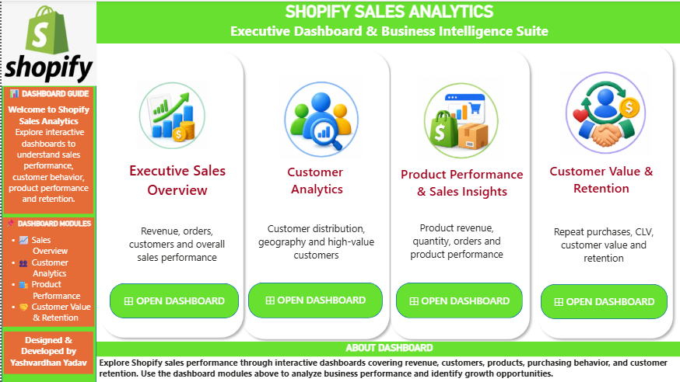
4.1 Data Analysis Approach
The Shopify Sales Analytics project follows a structured Business Intelligence approach to transform Shopify transaction data into an interactive Power BI dashboard.
The analysis focuses on:
- Sales Performance
- Customer Analytics
- Product Performance
- Customer Value & Retention
- Transaction-Level Analysis
4.2 Data Preparation & KPI Analysis
The transaction data was organized for analysis across key business dimensions including orders, customers, products, product types, quantity, revenue, payment gateways, cities and time-related sales information.
Based on the prepared data, KPIs and calculated measures were created, including:
- Total Orders
- Total Revenue
- Unique Customers
- Average Order Value
- New & Returning Customers
- Repeat Purchase Rate
- Customer Lifetime Value
- Total Products
- Total Product Types
- Total Quantity Sold
These KPIs provide a summarized view of sales, customers, products and retention performance.
4.3 Interactive Dashboard Design
The dashboard was designed as an interactive reporting solution using Power BI filters, slicers and visual interactions.
Users can analyse the dashboard based on dimensions such as:
- Gateway
- Product Type
- City
- Customer Type
Changes in selections dynamically update the relevant KPIs and visualizations.
4.4 Dashboard Structure
The dashboard is divided into analytical pages, with each page focusing on a specific business requirement:
- Executive Sales Overview – Overall sales KPIs, gateway, product and time analysis.
- Customer Analytics – Customer type, location, revenue and top-customer analysis.
- Product Performance – Product revenue, quantity, orders and AOV analysis.
- Customer Value & Retention – Repeat purchasing, customer value and retention metrics.
- Executive Business Summary – Business insights and recommendations.
- Order & Transaction Details – Detailed transaction-level analysis.
4.5 Transaction & Business Insight Analysis
The transaction-level section connects summarized KPIs with detailed records such as customer, customer type, city, order, product type, quantity, gateway and revenue.
The Executive Business Summary further converts analytical results into meaningful business insights and recommendations.
4.6 Overall Methodology
Sales Data → Data Preparation → KPI & Measure Creation → Visualization → Interactive Analysis → Business Insights → Recommendations
This methodology enables the dashboard to provide both quantitative performance measurement and actionable business interpretation.
5. DASHBOARD DEVELOPMENT & KPI ANALYSIS
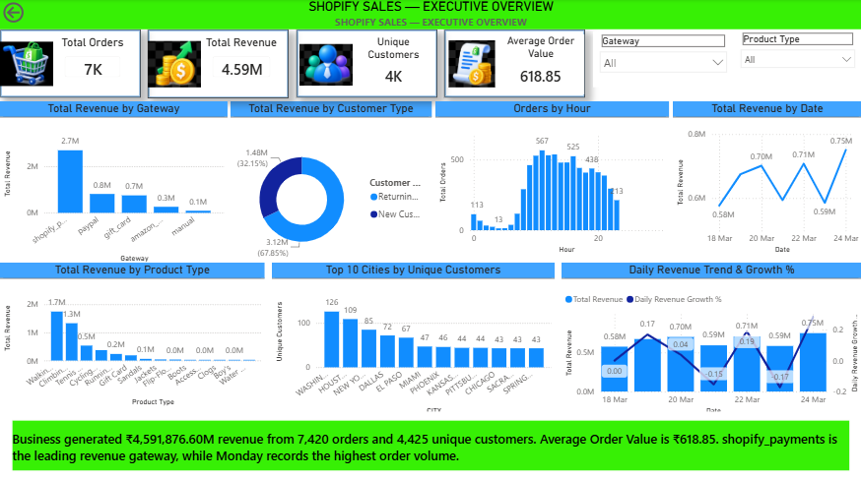
5.1 Dashboard Development
The Shopify Sales Analytics dashboard was developed using Microsoft Power BI to provide an interactive view of sales, customer, product and retention performance.
The dashboard combines KPIs, charts, filters, tables and dynamic business insights, allowing users to move from executive-level performance to detailed transaction analysis.
5.2 Key Performance Indicators
The major KPIs used across the dashboard are:
Analytical Area | Key KPIs
Sales Performance | Total Orders: 7,420; Total Revenue: ₹45.92 Lakh; Unique Customers: 4,425; AOV: ₹618.85
Customer Analytics | New Customers: 2,388; Returning Customers: 2,037; Orders per Customer: 1.68
Product Performance | Total Products: 202; Product Types: 14; Quantity Sold: ~8K; Revenue per Product: ~₹22.73K
Customer Retention | Repeat Purchase Rate: 46.0%; Purchase Gap: 2.03; CLV: ₹12,452.55; Returning Customer Revenue Share: 67.9%
These KPIs provide a summarized view of the business across sales, customers, products and retention.
5.3 Visual Analytics
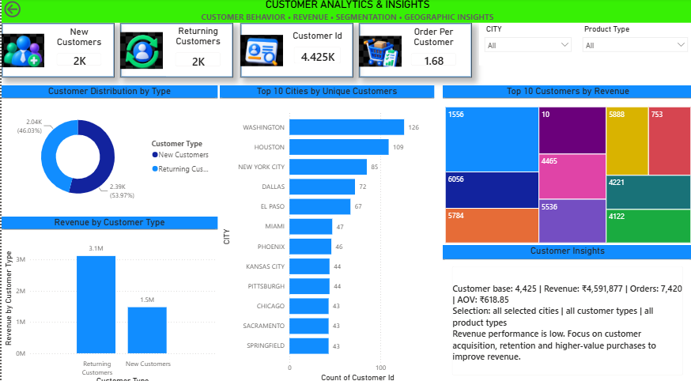
Along with KPI cards, the dashboard uses interactive visualizations to analyse:
- Revenue by Customer Type
- Revenue by Product Type
- Revenue by Gateway
- Orders by Hour
- Daily Revenue and Growth
- Customer Distribution and City Analysis
- Top Customers by Revenue
- Product Quantity and Revenue
- Orders and AOV by Product Type
- Customer Purchase Frequency
These visuals help identify trends, comparisons and performance patterns.
5.4 Interactive Dashboard Features
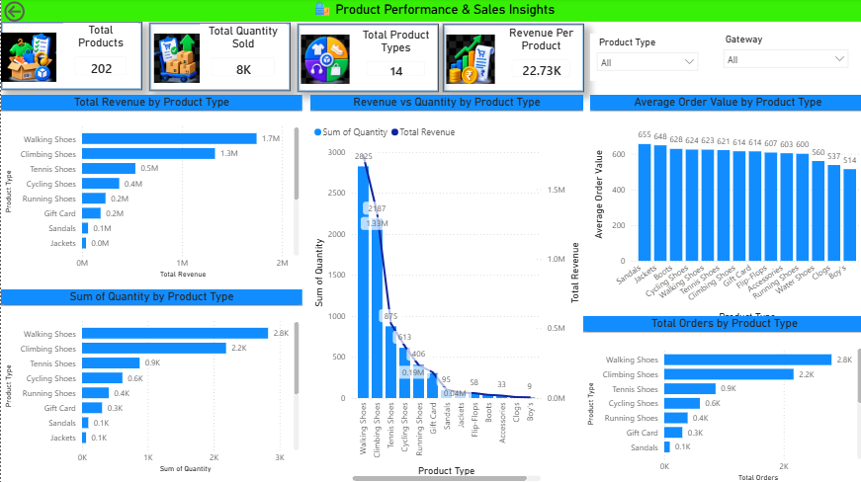
The dashboard includes interactive filters and slicers for:
- Gateway
- Product Type
- City
- Customer Type
Selections dynamically update the relevant KPIs and visuals, allowing users to analyse different business scenarios through a single dashboard.
5.5 KPI-to-Detail Analysis
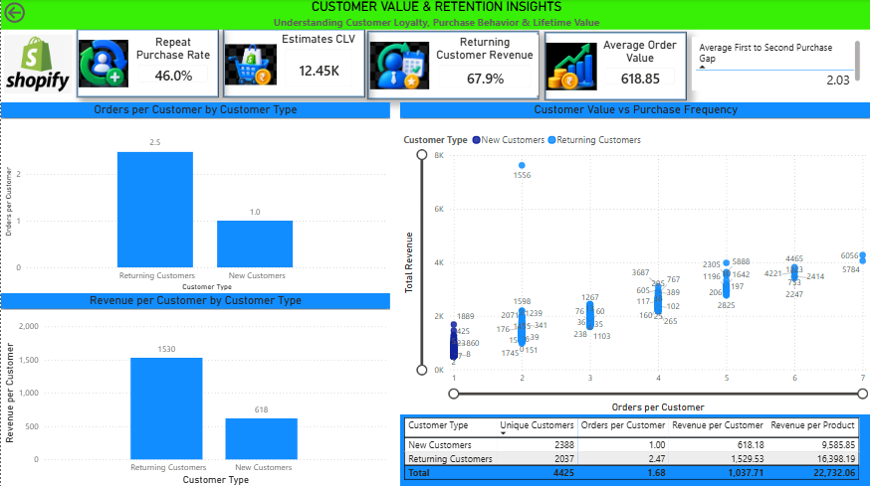
The dashboard connects summarized KPIs with detailed transaction-level information.
Users can move from a KPI to detailed records containing:
Customer → Customer Type → City → Order → Product Type → Quantity → Gateway → Revenue
This enables deeper investigation of the factors behind overall business performance.
5.6 Executive Business Summary
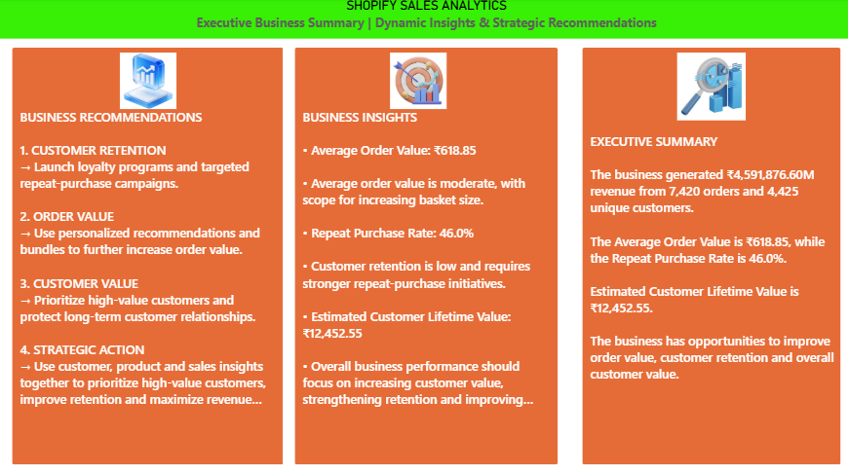
The Executive Business Summary converts dashboard results into management-oriented information through:
- Business Insights
- Business Recommendations
- Executive Summary
This helps decision-makers understand important findings and identify potential areas for improvement.
5.7 Overall Dashboard Value
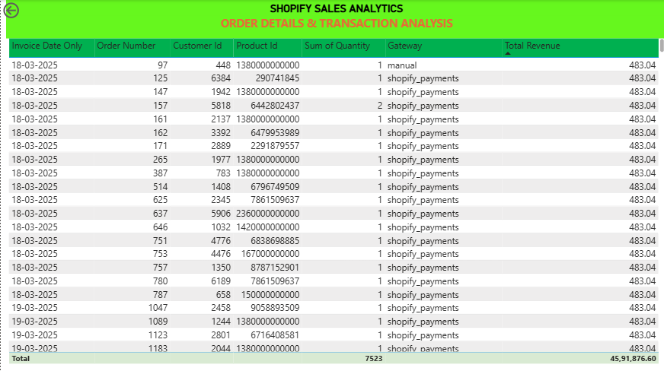
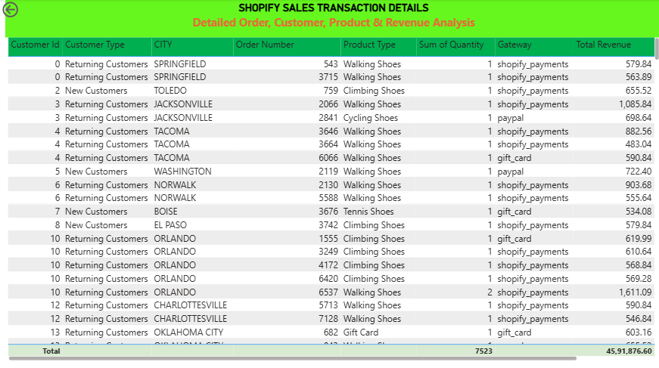
The dashboard supports analysis at three levels:
- Executive Level – KPIs and overall business performance.
- Analytical Level – Customer, product, gateway, geographical and retention analysis.
- Detailed Level – Transaction and customer/product records.
Overall, the dashboard provides a dynamic Business Intelligence solution that combines performance monitoring, interactive analysis and actionable business information.
6. BUSINESS INSIGHTS & ANALYSIS
6.1 Overall Business Performance
The Shopify Sales Analytics dashboard reports 7,420 total orders, ₹45.92 lakh revenue, 4,425 unique customers and an Average Order Value of ₹618.85.
These KPIs provide an overall view of business performance, while interactive analysis allows performance to be explored by customer type, product type, gateway, city and time.
6.2 Customer & Retention Insights
The customer base consists of 2,388 new customers and 2,037 returning customers.
Returning customers contribute approximately 67.9% of displayed revenue and show higher purchase frequency (2.47 orders/customer) compared with new customers (1.00 order/customer).
The dashboard also reports a 46.0% Repeat Purchase Rate and an estimated Customer Lifetime Value of ₹12,452.55.
These results indicate that returning customers are an important source of revenue and customer retention is a key business opportunity.
6.3 Product Performance Insights
The dashboard contains 202 products across 14 product types, with approximately 8K units sold.
Walking Shoes are the strongest displayed product type by revenue at approximately ₹1.7M, followed by Climbing Shoes at approximately ₹1.3M.
Product revenue, quantity, orders and AOV comparisons help identify strong-performing categories and potential opportunities for product promotion, bundling and cross-selling.
6.4 Gateway, Geography & Time Insights
Shopify Payments is the leading displayed payment gateway by revenue.
Customer concentration also varies by location, with Washington (126), Houston (109) and New York City (85) among the leading displayed cities.
Order activity and revenue also vary across time, indicating opportunities for targeted promotions and operational planning during high- and low-demand periods.
6.5 Key Business Insights
The major findings from the dashboard are:
- Overall business performance includes 7,420 orders and ₹45.92 lakh revenue.
- Returning customers contribute a significantly higher share of revenue than new customers.
- The 46.0% repeat purchase rate highlights the importance of customer retention.
- Returning customers demonstrate higher purchase frequency and customer value.
- Walking Shoes and Climbing Shoes are major displayed contributors to product revenue.
- Shopify Payments is the leading displayed payment gateway.
- Customer demand varies across cities and time periods.
6.6 Management Interpretation
The analysis indicates that customer retention, customer value and high-performing products are key areas of business opportunity.
Increasing repeat purchases, promoting high-performing products and using customer, geographical and time-based insights can help improve business performance.
Overall, the dashboard converts sales and customer data into actionable insights that support data-driven business decision-making.
7. BUSINESS RECOMMENDATIONS
Based on the Shopify Sales Analytics dashboard, the following recommendations can help improve customer value, revenue performance and business growth.
7.1 Strengthen Customer Retention
Returning customers contribute approximately 67.9% of displayed revenue and show higher purchase frequency than new customers.
The business should focus on:
- Loyalty and rewards programmes.
- Personalized offers.
- Repeat-purchase campaigns.
- Post-purchase communication.
- Returning-customer incentives.
Increasing repeat purchases can improve customer lifetime value and revenue stability.
7.2 Increase Average Order Value
The current Average Order Value is approximately ₹618.85.
The business can increase AOV through:
- Product bundling.
- Cross-selling.
- Personalized recommendations.
- Minimum-order-value offers.
- Complementary product suggestions.
This can increase revenue from existing transactions.
7.3 Focus on High-Performing Products
Walking Shoes and Climbing Shoes are major displayed contributors to product revenue.
The business should:
- Maintain adequate inventory.
- Promote high-performing categories.
- Use them in product bundles.
- Recommend complementary products.
Lower-performing products should also be reviewed for pricing, promotion, demand and inventory performance.
7.4 Use Customer and Geographic Insights
Customer concentration varies across cities, with locations such as Washington, Houston and New York City among the leading displayed cities.
The business can use these insights for:
- Location-based campaigns.
- Targeted advertising.
- Regional promotions.
- Personalized product recommendations.
High-value customers can also be targeted with exclusive offers and loyalty benefits.
7.5 Optimize Payment and Time-Based Strategies
Shopify Payments is the leading displayed payment gateway by revenue.
The business should continue monitoring payment-channel performance while maintaining a smooth checkout experience.
Similarly, hourly and daily sales patterns can be used to schedule promotions, marketing campaigns and operational resources during appropriate periods.
7.6 Build Continuous Business Intelligence
The dashboard should be used as an ongoing performance-monitoring tool rather than a one-time report.
Management should regularly monitor:
- Revenue and Orders
- Customer Growth
- Returning Customer Contribution
- Product Performance
- Repeat Purchase Rate
- Customer Lifetime Value
- Payment Gateway Performance
Regular monitoring can help identify changes in business performance and enable timely decisions.
7.7 Priority Recommendation
The highest-priority strategy is to strengthen customer retention and customer value, while simultaneously increasing Average Order Value and promoting high-performing products.
The dashboard indicates that returning customers contribute strongly to revenue and demonstrate higher purchasing activity. Therefore, the business should prioritize repeat purchases, personalized engagement, cross-selling and loyalty strategies.
Overall, combining customer, product, geographical, payment and time-based insights can help the business improve revenue performance and make more effective data-driven decisions.
8. CONCLUSION & FUTURE SCOPE
8.1 Conclusion
The Shopify Sales Analytics project successfully demonstrates the use of Microsoft Power BI to transform Shopify sales and customer transaction data into an interactive Business Intelligence solution.
The dashboard provides a consolidated view of sales performance, customer behaviour, product performance, customer value, retention and transaction-level analysis. It includes important KPIs such as Total Orders, Total Revenue, Unique Customers, Average Order Value, Repeat Purchase Rate and Customer Lifetime Value.
The analysis highlights the importance of returning customers, customer retention and high-performing product categories in overall business performance. Interactive filters, visual analytics and transaction-level details allow users to move from high-level performance monitoring to detailed investigation.
The Executive Business Summary further converts analytical results into business insights and recommendations, making the dashboard useful for management-level decision-making.
Overall, the project demonstrates how Power BI can simplify raw transaction data and provide a structured, interactive environment for business performance monitoring and data-driven decision-making.
8.2 Key Project Outcomes
The major outcomes of the project include:
- Development of an interactive Shopify Business Intelligence dashboard.
- Creation of executive-level sales and customer KPIs.
- Analysis of customer, product and retention performance.
- Geographical, payment gateway and time-based analysis.
- Integration of transaction-level details with summarized KPIs.
- Development of dynamic business insights and recommendations.
8.3 Future Scope
The dashboard can be further enhanced with the following capabilities:
1. Sales Forecasting
Predict future revenue and order trends using historical sales data.
2. Customer Churn & Segmentation
Use Machine Learning to identify at-risk customers and create segments such as high-value, loyal and regular customers.
3. Profitability & Inventory Analysis
Include product cost, profit margin, discounts, inventory levels, stock-outs and inventory turnover for deeper business analysis.
4. Advanced Product Recommendations
Implement recommendation techniques to identify complementary products and improve cross-selling opportunities.
5. Automation & Mobile Optimization
Introduce automated data refresh and optimize the dashboard for mobile devices to enable continuous and convenient business monitoring.
8.4 Final Statement
The Shopify Sales Analytics project provides a strong foundation for Business Intelligence-driven decision-making. By combining KPIs, interactive visualizations, customer and product analysis, retention metrics, dynamic insights and transaction-level details, the dashboard can support both executive monitoring and detailed business analysis.
The solution can be further extended into a more advanced predictive and automated Business Intelligence platform.

